Project Report: Tax Calculation Management System
1. Cover Page
PROJECT REPORT: Tax Calculation Management System
DEVELOPER: Madusri
DATE OF SUBMISSION: September 29,2026
REPOSITORY LINK: https://github.com/madusri26mip10100-bit/Tax-calculation-and-management-system.git
2. Introduction
The Tax Calculation Management System is a command-line utility designed to evaluate individual tax liabilities based on defined income brackets. Implemented in a single Python script, the application allows users to input their personal and financial details to instantly generate a comprehensive tax report. Furthermore, it features basic data persistence, allowing users to save, view, and search past tax records stored in a local text file.
3. Problem Statement
Individuals often require a straightforward method to estimate their annual tax liability without navigating complex software. Manual calculation of tax brackets, deductions, and cesses is prone to human error. There is a need for a lightweight, accessible tool that automatically applies specific tax rules—such as a 5%, 20%, and 30% slab rate, applicable rebates for incomes under ₹5,00,000, and a standard 4% health and education cess—while keeping a persistent log of previous calculations for future reference.
4. Functional Requirements
- Tax Calculation: The system must accept user inputs for Name, Age, Occupation, Annual Salary, Other Income, and Deductions.

- Income Processing: The system must compute Gross Income (Salary + Other) and Taxable Income (Gross - Deductions, bounded to a minimum of 0).

- Tax Logic Execution: The system must apply standard tax slabs (0 up to 2.5L, 5% up to 5L, 20% up to 10L, 30% above 10L).

- Rebates & Cess: The system must apply a full tax rebate if the taxable income is ₹5,00,000 or less, and add a 4% cess on the post-rebate tax amount.

- Record Saving: The system must append the calculated report variables (Name, Age, Occupation, Gross, Deduction, Taxable, Final Tax, Net Income) as a comma-separated line into tax_records.txt.

- Record Viewing & Searching: The system must read and display all contents of tax_records.txt, and allow case-insensitive searching by the user's name.

5. Non-functional Requirements
- Usability: The system provides an interactive, loop-based main menu for straightforward terminal navigation.

- Reliability (Error Handling): The system must gracefully handle file access errors, specifically trapping FileNotFoundError if a user attempts to view or search records before tax_records.txt is created.

- Simplicity: The system operates without external database dependencies, relying purely on standard Python built-in functions.

6. System Architecture
=================================================
SYSTEM ARCHITECTURE DIAGRAM
=================================================

+-----------------------+
| USER |
+-----------+-----------+
|
| (Terminal Input / Output)
v
+-----------------------+
| PRESENTATION | <-- Command Line Interface
| (Main Menu) | (madusri 26MIP10100.py)
+-----------+-----------+
|
| (Function Calls)
v
+-----------------------+
| BUSINESS LOGIC |
| - calculate() |
| - tax(income) |
| - view/search logic |
+-----------+-----------+
|
| (File I/O Operations)
v
+-----------------------+
| DATA LAYER | <-- Flat File Storage
| (tax_records.txt) |
+-----------------------+

7. Design Diagrams
Use Case Diagram
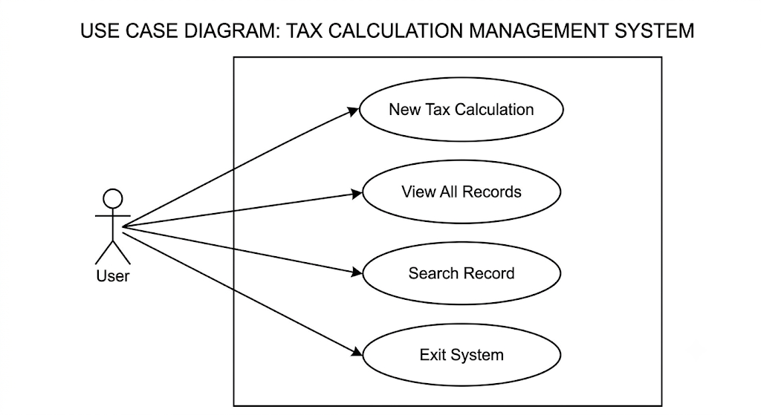

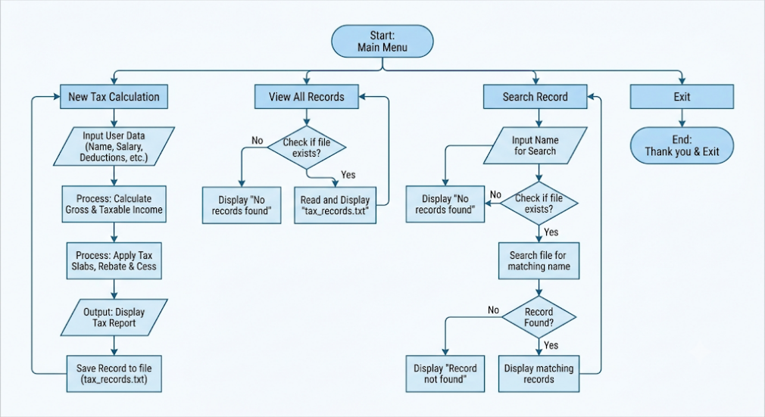
Workflow Diagram
Sequence Diagram (Tax Calculation)
- User -> System: Selects Option 1 (calculate()).
- System -> User: Prompts for inputs (Name, Salary, Deductions, etc.).
- System -> tax(income): Passes Taxable Income for slab evaluation.
- tax(income) -> System: Returns Basic Tax amount.
- System -> User: Displays formatted ========== TAX REPORT ==========.
- System -> tax_records.txt: Opens in "a" (append) mode and writes CSV data.

Class/Component Diagram
The system uses a procedural design rather than object-oriented classes. The core functional components are:

- tax(income): Core mathematical logic.
- calculate(): I/O handling and aggregation of financial data.
- view_records(): File reading component.
- search_record(): String matching and data retrieval component.

ER Diagram (Storage Layout)
- Entity: TaxRecord
- Attributes: Name (String), Age (Integer), Occupation (String), Gross (Float), Deduction (Float), Taxable (Float), Tax (Float), Net (Float).
- Relationship: Stored as comma-separated values per line in a flat text file.

8. Design Decisions & Rationale
- Procedural Approach: Functions were utilized instead of classes to minimize overhead for a simple, single-purpose calculation script.

- Flat-file Data Storage: Using tax_records.txt avoids the need to install database software (like SQLite or MySQL), making the script instantly portable.

- Case-insensitive Search: User search queries and file lines are converted to .lower() to ensure reliable record retrieval regardless of how the user types the name.

9. Implementation Details
The script madusri 26MIP10100.py runs an infinite while True: loop acting as the main controller.

- Tax Slabs: Implemented using a standard if-elif-else ladder bounded at ₹2,50,000, ₹5,00,000, and ₹10,00,000 limits.

- File I/O: Record creation uses Python's standard open(file, "a") for non-destructive appending. Record reading uses open(file, "r").

- Data Formatting: Outputs in the terminal are rounded to two decimal places using round(value, 2) to simulate financial formatting.

10. Screenshots / Results
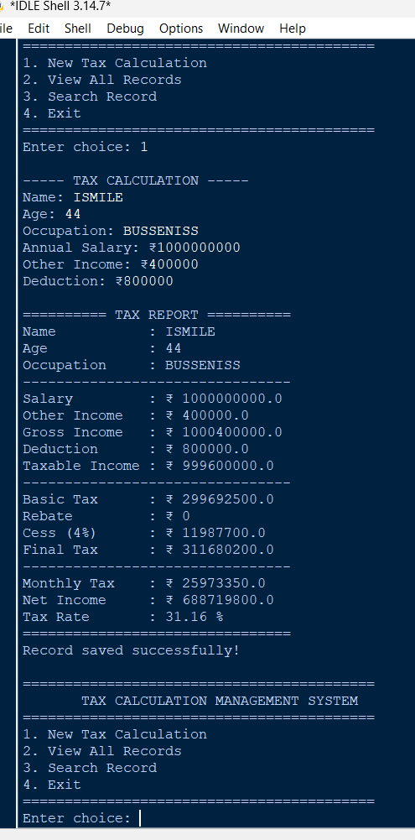

11. Testing Approach
Testing for this system requires validating both the mathematical logic and file system interactions:

- Boundary Value Testing: Testing an exact taxable income of ₹5,00,000 to ensure the rebate logic correctly applies. Testing an exact income of ₹2,50,000 to ensure the zero-tax bracket holds.

- Negative Input Handling: Ensuring the system defaults taxable income to zero if deductions exceed gross income (max(0, gross - deduction)).

- Exception Testing: Running options 2 and 3 before any data is saved to verify the FileNotFoundError successfully prevents application crashes.

12. Challenges Faced
- String/Type Conversions: Ensuring that inputs for salary and deductions are safely cast to float while age is cast to int requires precise handling to avoid runtime ValueError crashes.

- String Formatting for File Persistence: Concatenating different data types (strings, floats, ints) into a single writable string requires wrapping numerical variables in str() before appending them to the file.

13. Learnings & Key Takeaways
- Modularizing logic (separating the raw tax() math from the calculate() user interface) makes the script cleaner and easier to maintain.

- Implementing graceful error handling (using try-except blocks for missing files) drastically improves user experience compared to unhandled traceback errors.

- Flat-file databases provide an excellent, lightweight solution for simple state-persistence in CLI applications.

14. Future Enhancements
- Input Validation: Adding try-except blocks around user inputs (e.g., preventing the app from crashing if a user types text when prompted for "Annual Salary").

- Data Serialization: Upgrading from raw CSV string concatenation to utilizing Python's built-in csv or json libraries for safer data parsing and structure.

- Dynamic Tax Brackets: Storing the tax brackets and rates in a configuration file so they can be updated annually without altering the core Python code.

- Graphical User Interface (GUI): Transitioning the command-line interface to a visual application using libraries like Tkinter or PyQt.

15. References
- Source Code File: madusri 26MIP10100.py

